Praying for Children - Karaki Mo Ngā Tamariki -
어린이를 위한 기도
Activities and resources:

WONDER- Play dough all age activity
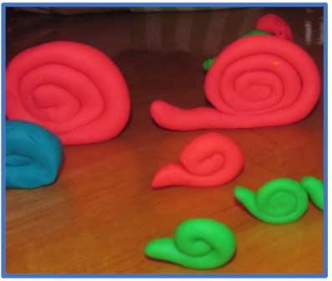
MATERIALS LIST: Play-doh (enough for a small fist-full for each person), prepare baggies of play-dough for each worshipper, set in baskets at the end of rows if sitting in pews or easily accessible for helpers to hand out to each person. You can do this as part of your response to the scripture reading or as an activity while the above conversations are happening.
INSTRUCTIONS:
- Invite everyone to respond to the Word by making a play-dough snail. This snail will be a companion and guide as we begin the week in wonder and explore child-like characteristics throughout this ‘Praying for Children’ week.
- It may be helpful to project a picture of a Play-dough snail for all to see an example. Consider inviting a child/youth who you have prepped beforehand to share an example they have made prior to worship. Children/youth could pair up with adults.
- Place step-by-step instructions onto the screen for those who would like them and talk them through but also leave it open for those who want to create their snail in their own way. Some will want instructions and others will not.
- Step-by-Step instructions: (if you prefer a video, there are many on YouTube, one suggested link: How to make play dough snail | Easily | For kids - Bing video)
  - Once you have your play-dough in hand, roll it within your hands to make a long rope
  - Take your long rope shape and roll it up to form the spiral shell of the snail, leaving a little bit of the rope shape at the end
  - Form the last part of the rope shape into the snail’s head
  - Have fun making it your own! You could mold part of the head into antennae or use a pencil or pen to etch some eyes (for fun!) or some designs into the shell.
  - Take your snail with you, placing it somewhere in your house where you will see it.
  - Blessing: May God guide us through this week slowly as a snail, remembering to open up to wonder, paying attention, innocence, curiosity, playfulness, ongoing questions, and trust through the eyes of a child!

Make your own Play-doh at home!
Easiest no cook play dough recipe - Kiwi Families

INNOCENCE- Hike and Hunt
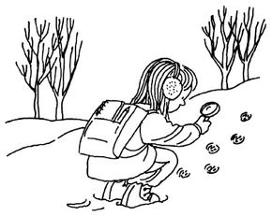
Hike and hunt is an engaging outdoor fitness activity for all
©2007 PUBLICATIONS INTERNATIONAL, LTD.
Hike and hunt is an easy fitness activity that gets kids outside and keeps them occupied for hours. Teach kids to keep their eyes on the great outdoors!
What You'll Need:
- Plastic magnifying glass
- Paper
- Pencil
How to Play Hike and Hunt:
Step 1: The next time you take a hike in the woods or a nature area in your neighbourhood, keep your eyes open for signs of wildlife. Are there bird feathers on the trail? Have local animals left tracks in the mud or sand? Are there bits of fur trapped in the bushes? What signs of nature can you find?
Step 2: What clues do those signs offer to the animals' ways of life? Use the magnifying glass for up-close looks at items that catch your eye. Make notes of your observations.
Step 3: Hike the same path a week later and make more observations. What has changed? What hasn't?
You can hike and observe regularly over a longer period, keep a nature journal, and learn something while you are exercising those legs!
Source: https://lifestyle.howstuffworks.com/crafts/home-crafts/easy-fitness-activities-for-kids.htm?utm_source=howstuffworks&utm_medium=recirc

Videos:
The Snail and the Whale by Julia Donaldson. Children's read-aloud story with illustrations. - YouTube

Hey Mary! – Music Video:
https://www.youtube.com/watch?v=PVoGcumJwng

Books:
The Snail and the Whale by Julia Donaldson
Caterpillar, Caterpillar by Vivian French
Escargot by Dashka Slater
http://www.picturebooktheology.com/2017/06/do-you-have-shimmery-trail.html

