Praying for Children –
Karaka Mo Ngā Tamariki
Become like a child ….
22 -28 August 2021

Titiro Whakamuri kokiri whakamua
Look back and reflect so you can move forward

We invite you this week to use the resources of the ‘Praying for Children’ initiative to engage with seven childlike qualities of remembering:

Wonder ….

Giving Attention ….

Innocence ….

Curiosity ….

Playfulness ….

Ongoing questions ….

Trust ….

Setting the scene for Praying for Children week
Matthew 18: 3b – 4
“Truly I tell you, unless you change and become like children, you will never enter the kingdom of heaven. Whoever becomes humble like this child is the greatest in the kingdom of heaven".

What you can expect to find in these resources :
On Sunday, resources for a service of worship with liturgical prayers, a short reflection with questions for conversation and an all age activity to engage with plus a take home practice.
Each day through the week a series of short prayers, quotes, poems, reflection questions and practices to explore a particular aspect to support the intentional formation of a childlike posture. All the resources we have created for you are on the blog. https://resourcingprayerandworship.wordpress.com/blog-2/
A child is dependent on adults to care and provide, to protect, teach and guide and so as we pray for children this week, we turn to God as a parent; the One who we can trust fully, wholly and completely. So, held and loved, we are courageous to love and hold in prayer.

THE RESOURCES
We have created a wonderful and insightful suite of resources to accompany each of the daily themes snippets of which are mentioned below:
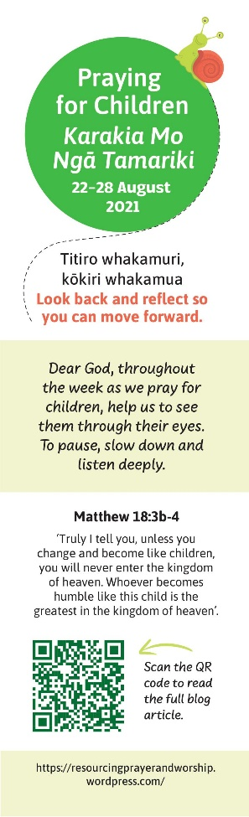
Bookmarks
On the back of the bookmark is the list of childlike qualities, one for each day.
Each day think about a different childlike quality, pray and engage in the actions and inspiring practices as outlined in Roxy’s daily blog post. Go to Rev Roxy Gahegan’s blog link: https://resourcingprayerandworship.wordpress.com/blog-2/ Or you can use the QR code to take you directly to the blog.
We encourage you to make these available to your whole congregation. Also, think about posting the blog link and daily prayers on your Facebook page and other social media.
Copies of the bookmark have been mailed out to churches. Further copies can be downloaded via the blog link. https://resourcingprayerandworship.wordpress.com/blog-2/
We have also translated the bookmark in Te Reo Maori, Samoan and Korean. Copies are available for down load via the blog link.

Intergenerational Playdough activity
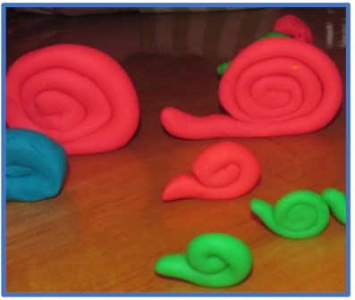
Play dough all age activity - Invite everyone to respond to the Word by making a play-dough snail. This snail will be a companion, a guide as we begin the week in wonder, and explore child-like characteristics throughout this ‘Praying for Children’ week.
Easiest no cook play dough recipe - Kiwi Families

Conversation Starters
• in small groups, brainstorm together the childlike qualities that you think might help to make us good disciples
• take turns telling a story from your childhood where you remember living out any one of the qualities you have come up with in your brainstorm - what was that like and why do you remember that story, do you think?
Let your snail remind you of the intention to slow down this week, to wonder and give attention to the challenge of childlike discipleship.

Power point, Stories & Poems for prayer and action
We gratefully acknowledge that all the poems are used with permission. (Administered in Australia and NZ by Willow Publishing Pty Ltd. www.willowpublishing.com.au. All rights reserved.)
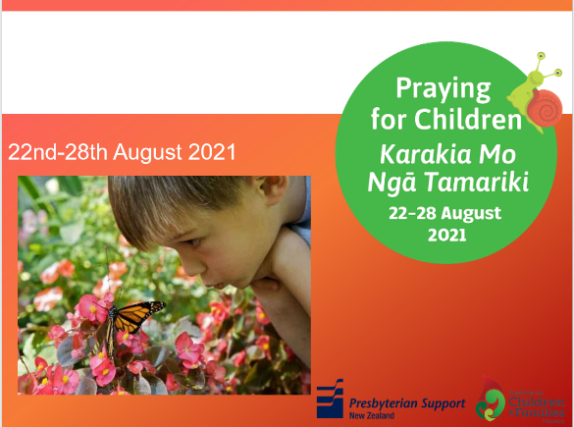
The seven childlike qualities are highlighted in the power point with a story or practice for each one. Depending on your time and context, choose some of the stories or practices below when sharing the PPT on Sunday 22 August, to introduce the week’s prayer focus.
For the power point and other resources go to and www.pcfm.org.nz and https://www.psn.org.nz/get-involved/community-connections/resources
Make the bookmarks available before or after the power point.

Activities, Practices & Stories
Below are some snippets of the ideas you will find in the blog. https://resourcingprayerandworship.wordpress.com/blog-2/

WONDER – practicing
Take your play dough snail home and put it somewhere to catch your eye to remind you of the intention to slow down this week, to wonder and give attention to the challenge of childlike discipleship.

GIVING ATTENTION – prayer
Dear God, today we pray for children as we think about how they pay attention…to the snail crawling along the path and the daisy opening to the morning sun

INNOCENCE – activity
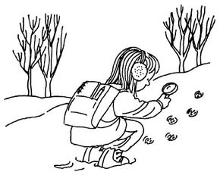
https://lifestyle.howstuffworks.com/crafts/home-crafts/easy-fitness-activities-for-kids.htm?utm_source=howstuffworks&utm_medium=recirc

Hike and hunt is an engaging outdoor fitness activity for kids.
©2007 PUBLICATIONS INTERNATIONAL, LTD.

CURIOSITY - practising
Take a ten-minute walk around your neighbourhood sometime today. Put on the eyes of a child as though you are seeing things for the first time. What makes you curious?

PLAYFULNESS – story - open us to energy and the joy of life
Laura, one of PSN’s Social Workers in Schools (SWiS) noticed that a number of children and their caregivers were struggling to connect at home. She wanted to find a way for children and their parents/caregivers to connect more intentionally and learn to play together and strengthen the relationship between them.
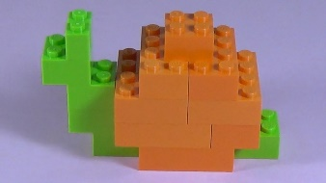
Lego was the answer!
The vision is for the 600 families at Redoubt Road Primary School to have a set of lego to play with at home. So far 200 sets have been purchased so if you would like to help this school achieve this goal please contact us. Anne.overton@psn.org.nz
The home based programme known as Brick By Brick has been evaluated by PSN’s Service and Evaluation team. https://www.psn.org.nz/download/brick-by-brick-outcome-evaluation

ONGOING QUESTIONS - activity

Sit and make a list of ten questions you have about the world.

TRUST – story
Give thanks for those who you trust and for those who trust you
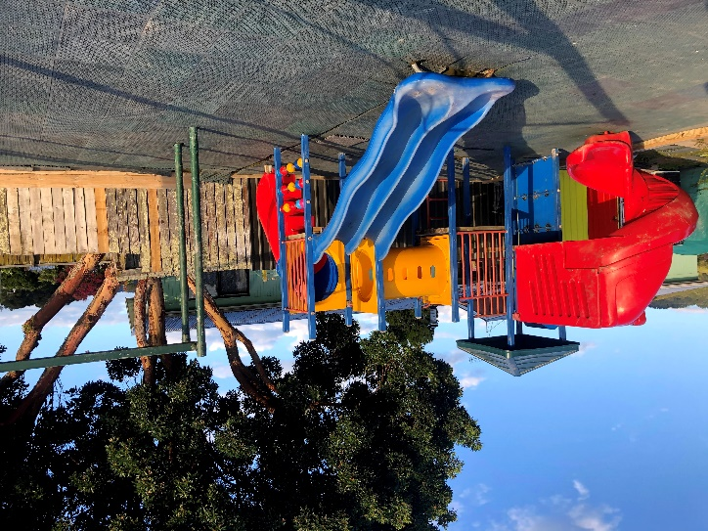
Josh, a little 3-year-old boy with autism loves the new playground at the Hughes Place Community Garden in Tāneatua.
Prior to the Saint Kentigern Boys’& Girls’ School service project, Josh would be found wandering naked around the township of Tāneatua, having disappeared from his grandmother’s home.
Now with the new playground, Josh’s grandmother knows exactly where he is and knows that he is safe and lovingly watched over by the neighbourhood. Josh now arrives with clothes on because Honey Thrupp, one of the garden’s kaitiaki told him when he comes to the garden he needs to wear at least underpants.

Who do you trust? Where are the safe places for you to go if your safety was an issue?
Talk about these situations with people at church, in your home, in your neighbourhood. Support from shine and Lifeline are always available.
This community is a child rich community. It is a community where the wellbeing of children, whanau and communities are closely interconnected.
https://www.childrichcommunities.org.nz/

THE RESOURCE TEAM
The Praying for Children team comprises of Rev Roxy Gahegan, Robin Humphrey’s, Rev Sharon Ross Ensor, Cindy Jang Barlow and Anne Overton.
We hope you and all ages in your congregation will find this a rich and useful resource.
The link to the blog is https://resourcingprayerandworship.wordpress.com/blog-2/

For the powerpoint and other resources go to www.pcfm.org.nz and to PSN’s website https://www.psn.org.nz/get-involved/community-connections/resources
Children’s Books & Videos

Videos:
- The Snail and the Whale by Julia Donaldson. Children's read-aloud story with illustrations. - YouTube
- Hey Mary! – Music Video:
https://www.youtube.com/watch?v=PVoGcumJwng

Books:
- The Snail and the Whale by Julia Donaldson
- Caterpillar, Caterpillar by Vivian French
- Escargot by Dashka Slater
http://www.picturebooktheology.com/2017/06/do-you-have-shimmery-trail.html

A special thank you to the Presbyterian Development Society of New Zealand.

